Page 1 of 2
AVAILS CURRENT AS AT 1 JANUARY 2016
EMILE SOLO / DREAMS DUO/TRIO / INFUSION DUO/ MT POCKETS DUO/ DJ EMS / EMS KARAOKE   |  |  | JOHN HUME / BONEY RIVERS /INFUSION DUO  
JAN AUSTRALIA DAY AVAILABLE!! |  |  | JAN
FRI | SAT | SUN | FRI | SAT | SUN
1 | 30 | NONE | 1, 8, 29 | 2, 30 | 31
FEB |  |  | FEB
FRI | SAT | SUN | FRI | SAT | SUN
5 | NONE | 21 | 26 | 27 | 7, 14
MAR |  |  | MAR
FRI | SAT | SUN | FRI | SAT | SUN
25 | 20 | NONE | 18, 25 | 5, 19, 26 | 13, 20, 27
GARY DAVIDSON  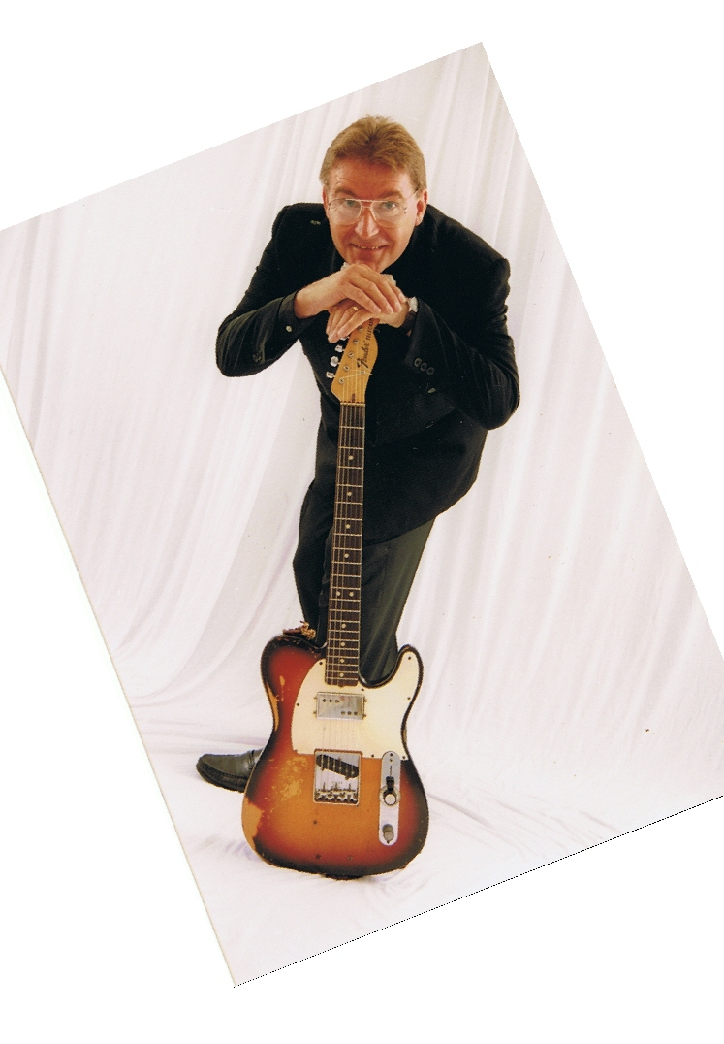 |  |  | PAUL FLAHERTY/ JAMES PAUL/ HEY PONCHO/ DIVISION 4  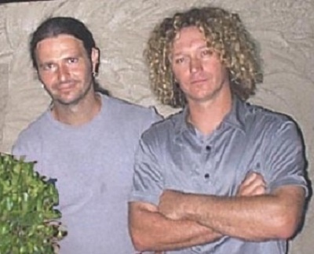
JAN AUSTRALIA DAY AVAILABLE!! |  |  | JAN AUSTRALIA DAY AVAILABLE!!
FRI | SAT | SUN | FRI | SAT | SUN
ALL | 23, 30 | 10, 24, 31 | 1, 8, 22, 29 | 2, 9, 23, 30 | ALL
FEB |  |  | FEB
FRI | SAT | SUN | FRI | SAT | SUN
5 | 26 | 28 | 12, 26 | 6, 27 | 7, 21, 28
MAR |  |  | MAR
FRI | SAT | SUN | FRI | SAT | SUN
4, 11, 18 | ALL | ALL | ALL | ALL | ALL
JOHN JAY / BACKBEAT  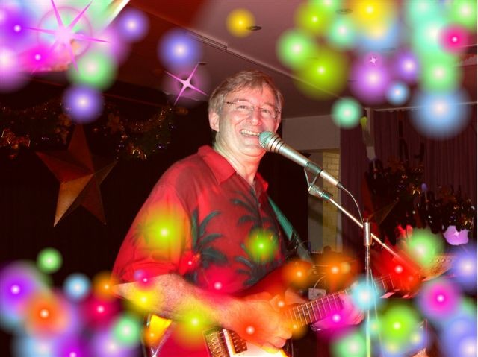 |  |  | RICK O’KEEFE / BACKBEAT  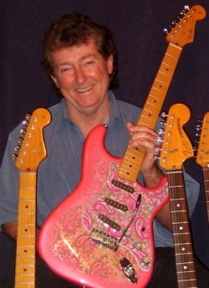
JAN AUSTRALIA DAY AVAILABLE!! |  |  | JAN AUSTRALIA DAY AVAILABLE!!
FRI | SAT | SUN | FRI | SAT | SUN
ALL | 2, 9, 16 | 10, 17, 24, 31 | ALL | 2, 16, 23 | 10, 17, 24
FEB |  |  | FEB
FRI | SAT | SUN | FRI | SAT | SUN
12, 26 | ALL | 7, 21, 28 | 5, 12, 26 | ALL | 7, 21
MAR |  |  | MAR
FRI | SAT | SUN | FRI | SAT | SUN
4, 11, 25 | 19, 26 | 13, 20, 27 | 4, 11, 25 | 5, 19, 26 | ALL
PETER STEFANSON  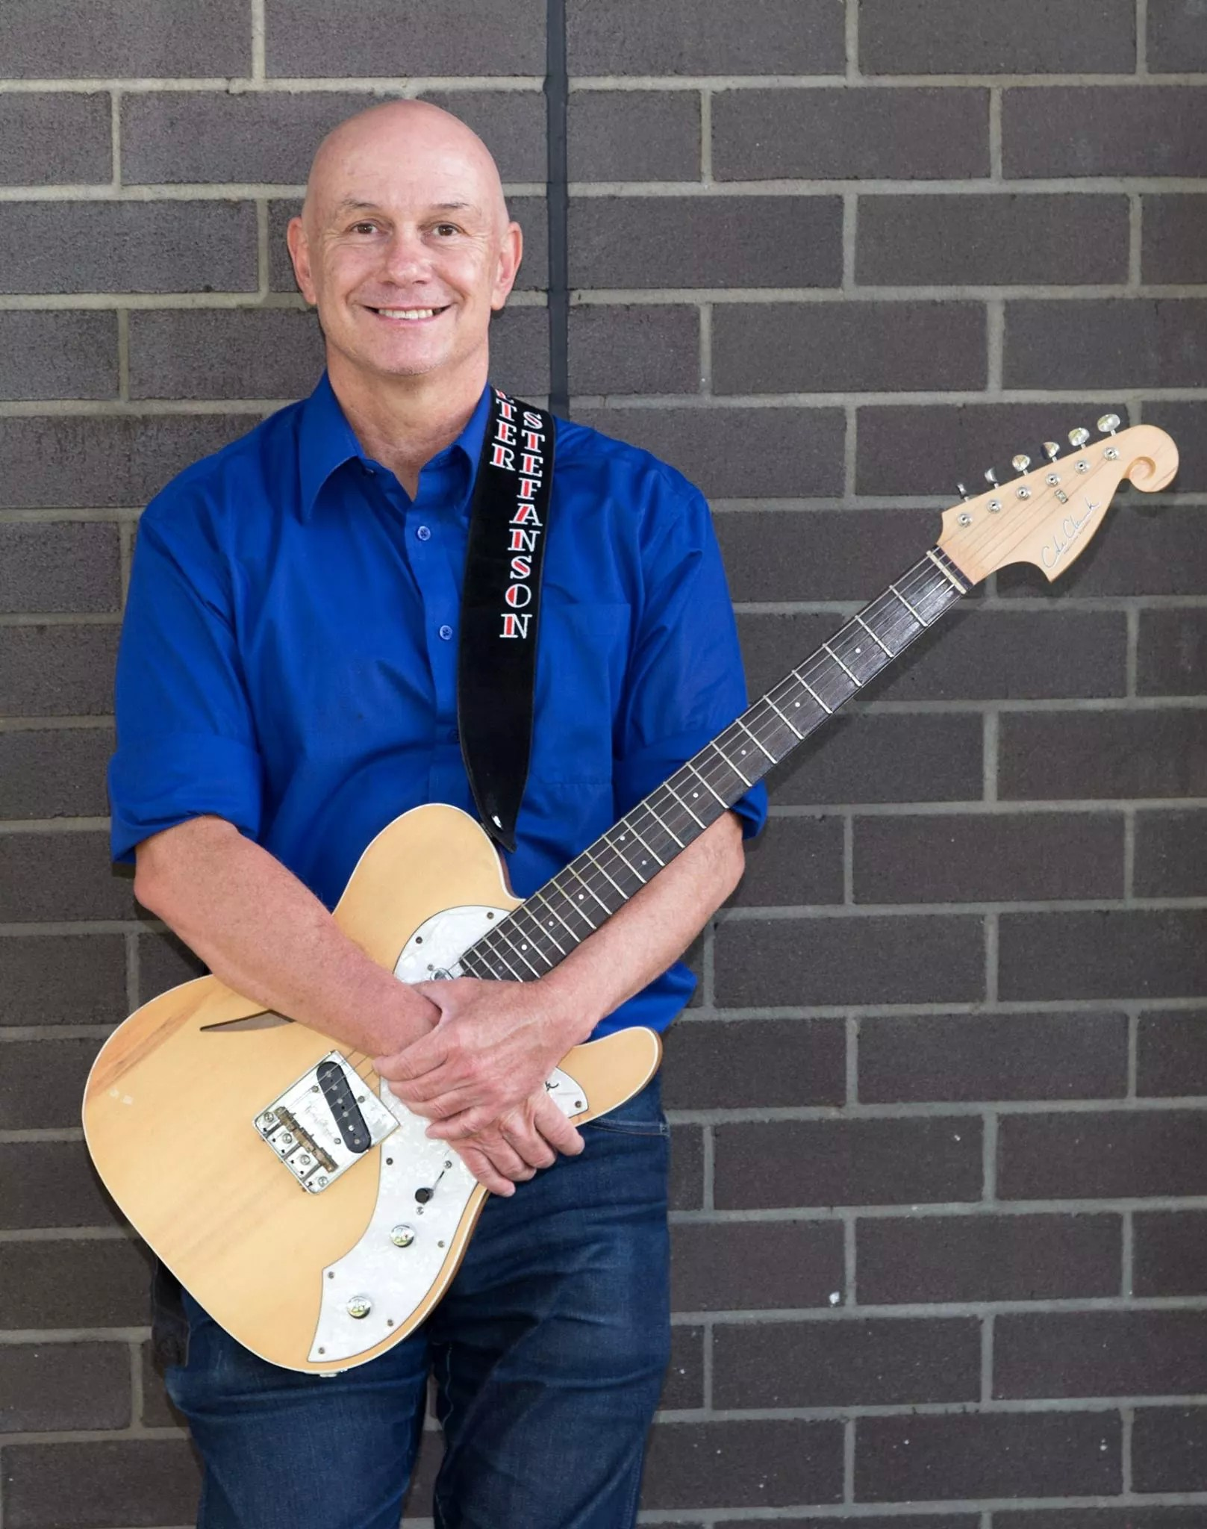 |  |  | RENE DIAZ “TOURING ARTIST”  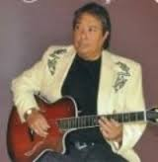
JAN AUSTRALIA DAY AVAILABLE!! |  |  | JAN AUSTRALIA DAY AVAILABLE!!
FRI | SAT | SUN | FRI | SAT | SUN
8, 22 | 2, 16, 30 | 10, 24, 31 | 29 | NONE | NONE
FEB |  |  | FEB
FRI | SAT | SUN | FRI | SAT | SUN
12 | 6, 13, 20, 27 | 14 | 5 | NONE | NONE
MAR |  |  | MAR
FRI | SAT | SUN | FRI | SAT | SUN
4, 11, 25 | 12, 26 | 13, 27 | 11 | NONE | 13

